**Faculty of Computer Science & Information Technology**

**University of Malaya**

**Semester 1, 2016/2017 Session**

**WIX2002: Project Management**

**Tutorial 4**

1. How does resource scheduling reduce flexibility in managing projects?

2. Why scheduling resources is an important task? Give five reasons.

3. How does resource scheduling tie to project priority?

4. Figure 1 shows a project network.

1. Compute the early, late, and slack times. What is the project duration (in weeks)?

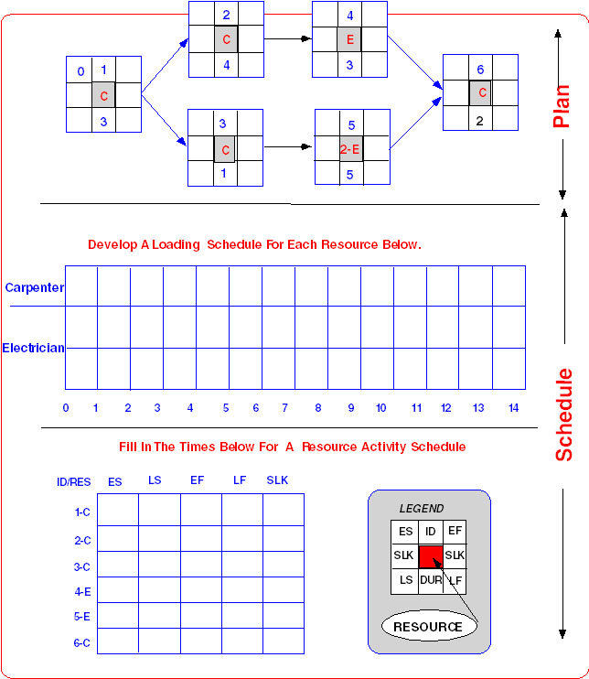

Figure 1: Project Network

1. Assume only one Carpenter, and two Electricians are available, respectively. Using Figure 2, develop a loading chart of resources for Carpenters (C), and Electricians (E).



Figure 2: Loading Chart of Resources for C and E

1. Based on your answers given (part b), compute the early, late, and slack times for the project. Draw the latest project network. Which activities are now critical? What is the project duration now?

5. Compute the early, late, and slack times for the activities as shown in Figure 3, assuming it is a time constrained network.

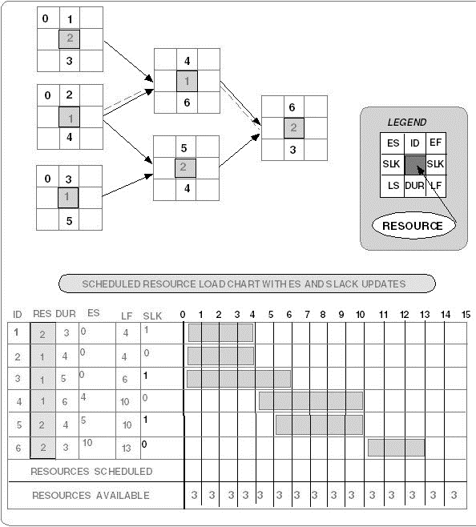

Figure 3: Project Network

1. Which activities are critical? What is the time constrained project duration with 3 maximum resource constraint?
2. Using the parallel method and the following heuristics priority rules:

Minimum slack

Smallest duration

Lowest identification number

schedule the project only one period at a time. Keep a log of each activity change and the update that you make each period. Use the load chart to assist you in scheduling.

1. List the order in which you scheduled the activities of the project. Which activities of the project are now critical?
2. Based on your answers given (part c), re-compute the slack for each activity. What is the slack for activities: 1, 4 and 5?

6. What are the three most common problems associated with multi-project resource scheduling? Explain briefing, how can outsourcing the project work alleviate these problems?

7. Why is scheduling overtime a popular choice for getting projects back on schedule? What are the potential problems for relying on this option?

8. Draw a project network from the following information.

|  |  |  |
| --- | --- | --- |
| **ACTIVITY** | **PREDECESSOR** | **DURATION (WEEK)** |
| A | None | 2 |
| B | A | 4 |
| C | A | 3 |
| D | A | 2 |
| E | B | 3 |
| F | C | 6 |
| G | C, D | 5 |
| H | E, F | 6 |
| I | G | 5 |
| J | H, I | 5 |

Activities B and C can be shortened to a minimum of 2 weeks.

Which activity would you shorten to reduce the project duration by 2 weeks? Why?

9. Assume the network and data that follow. Compute the total direct cost for each project duration. If the indirect costs for each project duration are $400 (19 time units), $350 (18), $300 (17), and $250 (16), compute the total project cost for each duration. Plot the total direct, indirect, and project costs for each of these durations on a cost-time graph. What is this cost? What is the optimum cost-time schedule for the project?

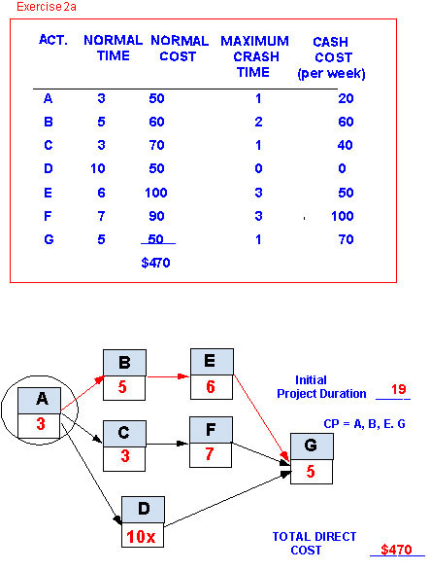



10. How can a cost-duration graph be used by the project manager? Explain.